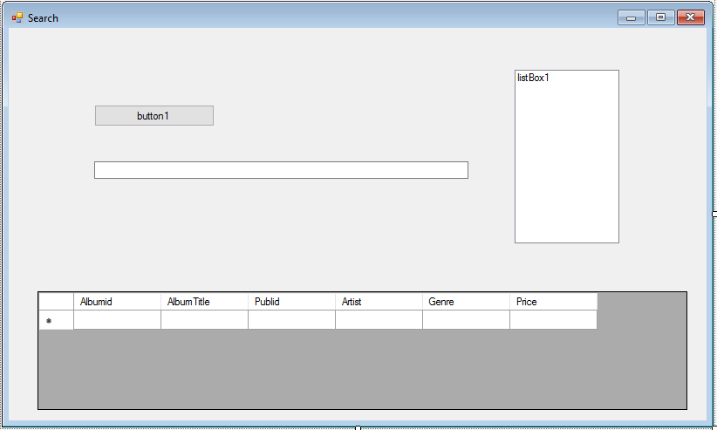

public partial class frmSearch : Form

{

public frmSearch()

{

InitializeComponent();

}

SqlConnection cnn;

string connectionString;

SqlCommand command;

String sql = "", Output = "";

SqlDataAdapter adapter = new SqlDataAdapter();

private void button1_Click(object sender, EventArgs e)

{

/*try

{*/

listBox1.Items.Clear();

command = new SqlCommand(sql, cnn);

command.CommandText = textBox1.Text.ToString();

cnn.Open();

SqlDataReader datareader = command.ExecuteReader();

if (datareader.HasRows)

{

while (datareader.Read())

{

listBox1.Items.Add(datareader[0].ToString() + " " + datareader[1].ToString());

}

}

else { listBox1.Items.Add("No Data Found!"); }

cnn.Close();

}

/*catch (Exception ex)

{

MessageBox.Show(ex.Message.ToString());

cnn.Close();

}

}*/

private void frmSearch_Load(object sender, EventArgs e)

{

connectionString = (@"Data Source = HH-W4-NEWTEST;Initial Catalog = Clive_Music; Integrated Security = True;");

cnn = new SqlConnection(connectionString);

cnn.Open();

MessageBox.Show("You have successfully connected to the Clive Music Database!");

cnn.Close();

// TODO: This line of code loads data into the 'clive_MusicDataSet.Album' table. You can move, or remove it, as needed.

//this.albumTableAdapter.Fill(this.clive_MusicDataSet.Album);

}

}

}

SQL Commands To Try

Select AlbumTitle, Artist from Album where Artist like ‘_i%’

Select AlbumTitle, Artist from Album where Artist in (‘David Bowie’, ‘Status Quo’)

Select AlbumTitle, Artist from Album where Price between ’11.99’ and ’12.98’

Select AlbumTitle, Artist from Album where Price < ’12.99’